# The Snowball

# Objectives

This activity allows collective analysis of a topic, by slowly confronting the point of views of the group’s participants. From the start, everyone contributes to the debate, which strengthens the feeling of belonging and having all contributed to the final thinking or proposal. This way, those who are less comfortable sharing their thoughts to a big group can participate from the beginning. This is a progressive maturation-thinking process.

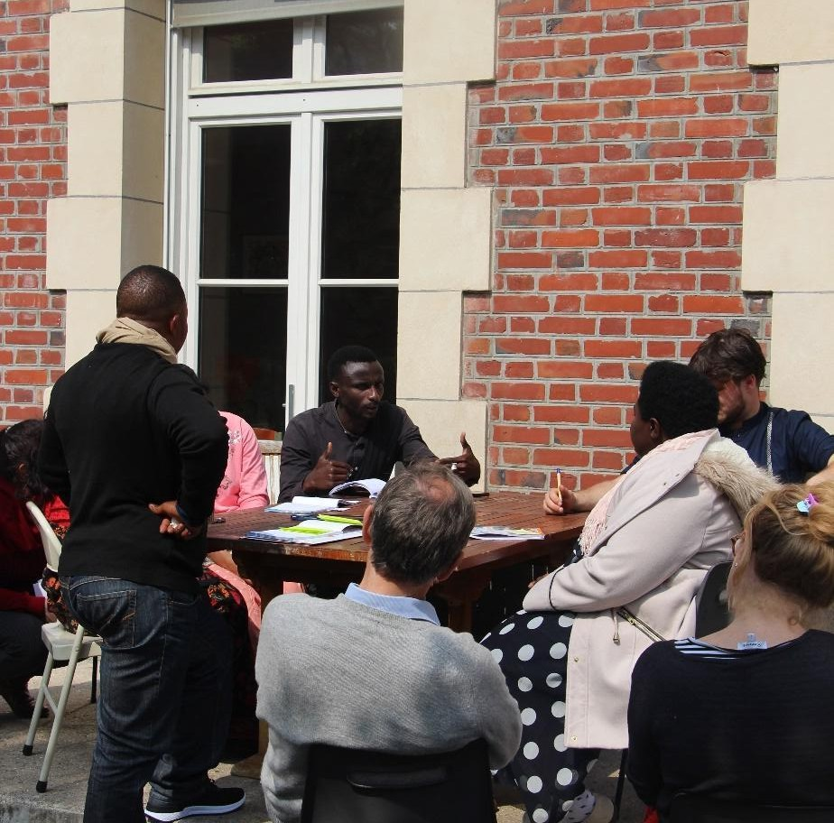

# Concrete application

This animation is usually done with large groups of at least 16 people, for at least an hour. It does not require any specific tool.

The animation starts off by introducing an issue, a question to participants, who debate it amongst them.

Announce the instructions to the participants by specifying the steps to follow:

* **Step 1 (10 min)** : The large group splits up in small groups of two, who discuss the issue. They should draft solutions to the issue. By the end of that step, each two-person team keeps one or two main ideas to present in the next step.
* **Step 2 (15 min)** : Each pair merges with another, and as a four-person group, they discuss the topic. Similarly to the previous step, each group keeps a couple of main ideas and presents them to the other pair to discuss it.
* **Step 3 (20 min)** : Each group of four joins another group, and participants are now eight to be debating. Each group of four kept a main idea from the preceding step, and present it to the other four people to discuss it..
* **Step 4 (over 30 min)** : Each group share their discussion to the rest of the assembly. This activity technique guarantees all participants contributed to the debate. Nevertheless, it must be minded that everyone agrees when one idea is ‘abandoned’, throughout the group debates. After the collective relaying, points of disagreement can be discussed.

*For instance, during the seminar Form to Transform in April 2023, we held this activity with the following main question : ‘How do you accompany groups to achieve a participative action?’. We asked groups to save, at each step, the proposal they thought was the most innovative.*

# A variation: the snowflake

For the snowflake variation, we start off by a time alone, then by two, four, eight people. The steps are the same, adding at the beginning a time for individual reflection (about 5 minutes).

# Point that the activity leader should mind

As the activity leader, you are in charge of time management and must ensure that each group joins another at the end of each step. You can remind them that they will have to pick only an idea or two to present to the next group.

You can also ensure the pairs and groups allow different types of actors/actresses to share ideas (for instance by mixing activity leaders with project coordinators in the pairs…)

When the eight-people group meets for the assembly, you will introduce the sharing by giving the floor to each group, and allowing them to react to the other group’s proposal and by ensuring a safe place to share ideas.

**URL Link of the article**:



Author:

